**The input demosalesmanager has been entered sucessfully**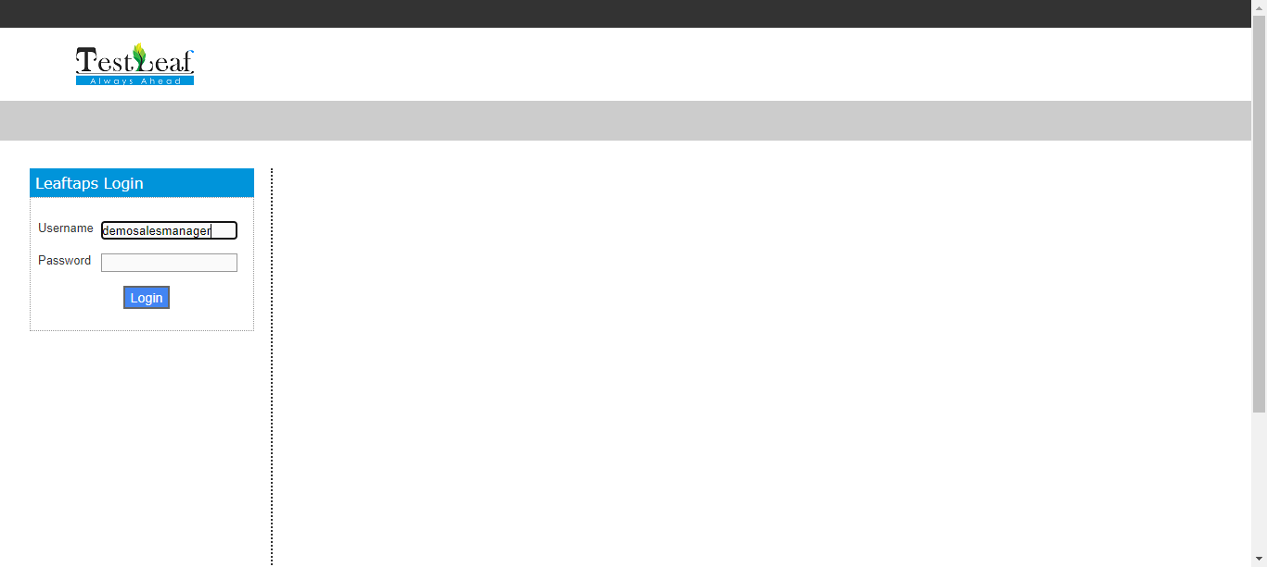

**The input crmsfa has been entered sucessfully**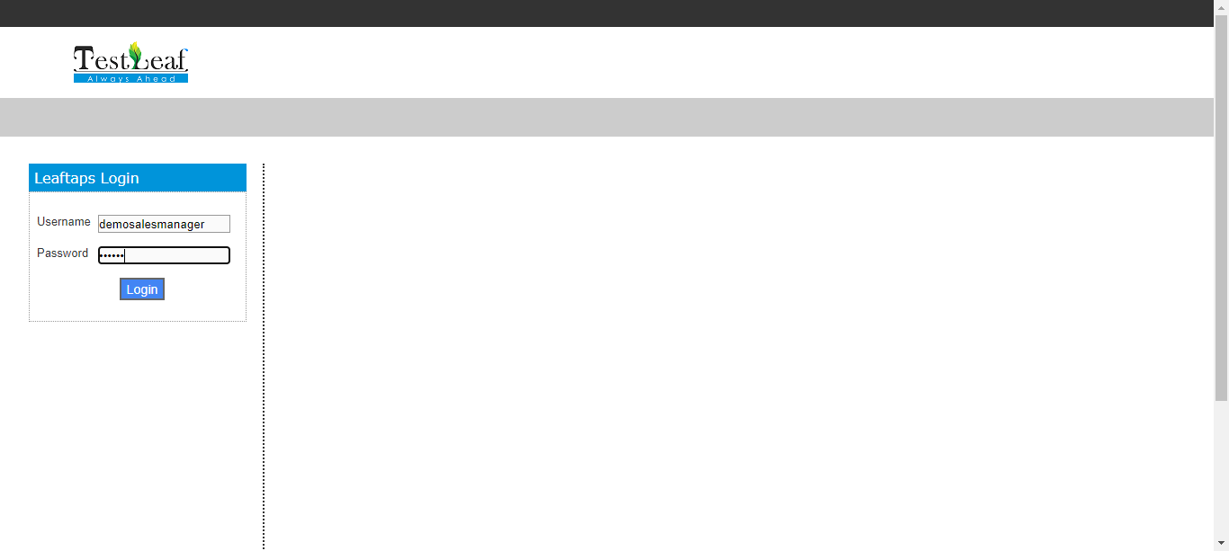

**The Element is clicked**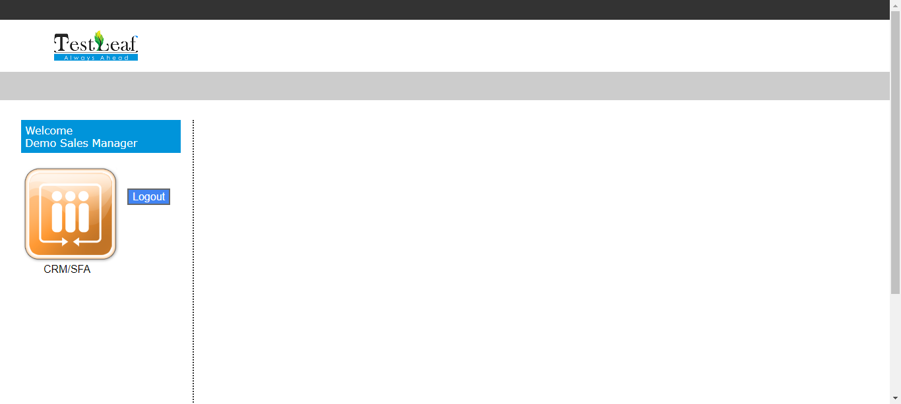

**The Element CRM/SFA is clicked**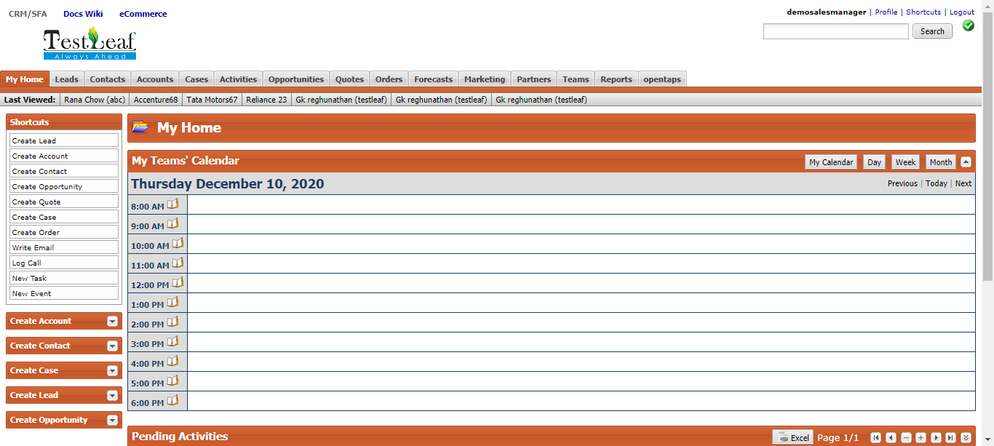

**The Element Accounts is clicked**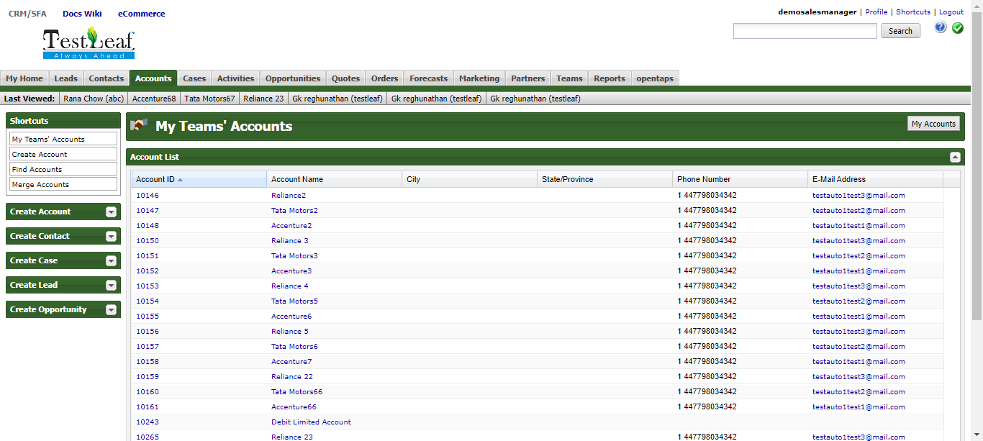

**The Element Create Account is clicked**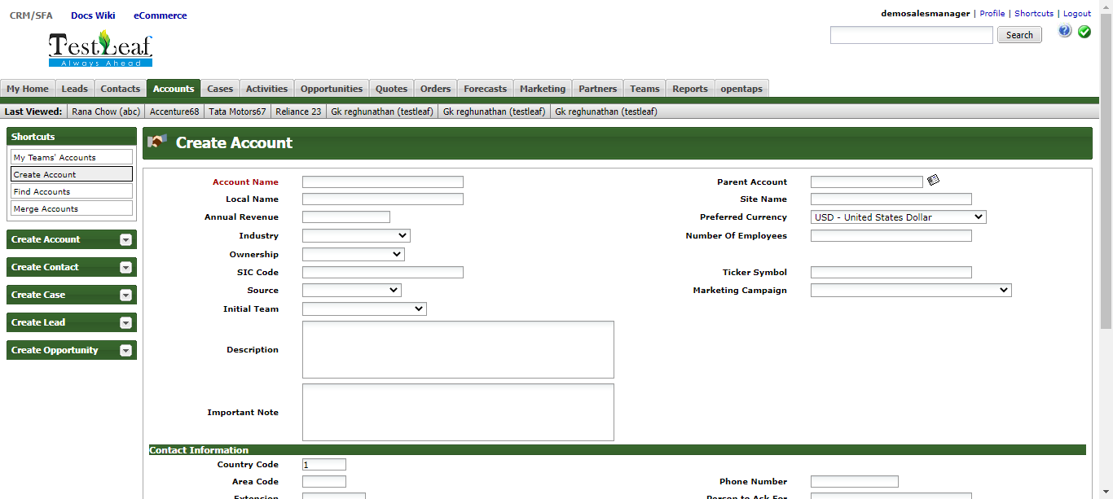

**The input Reliance 23 has been entered sucessfully**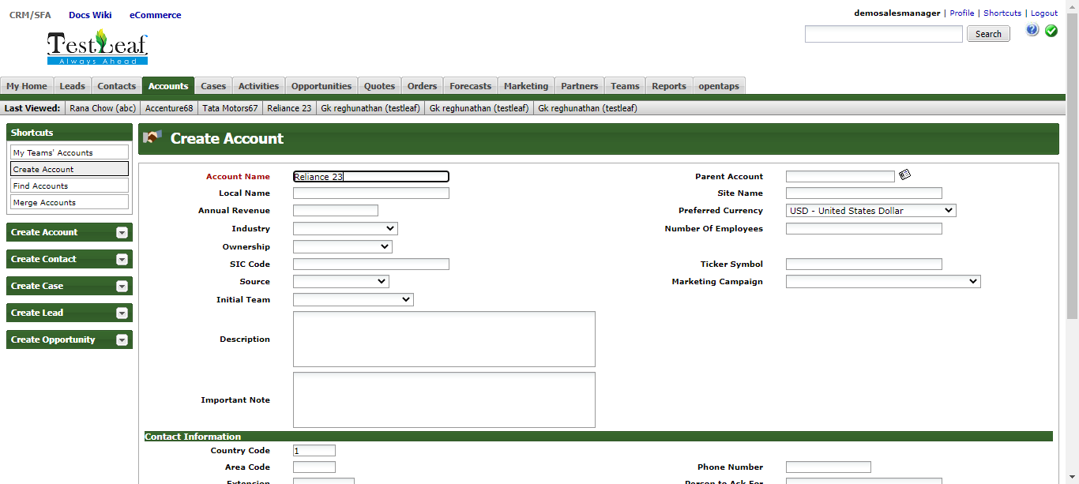

**The input 447798034342 has been entered sucessfully**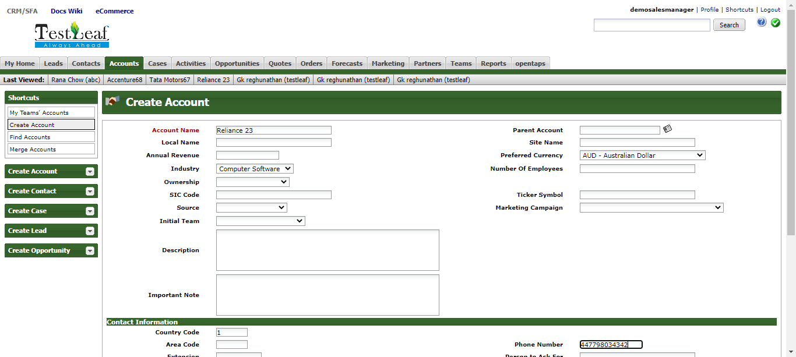

**The input testauto1test3@mail.com has been entered sucessfully**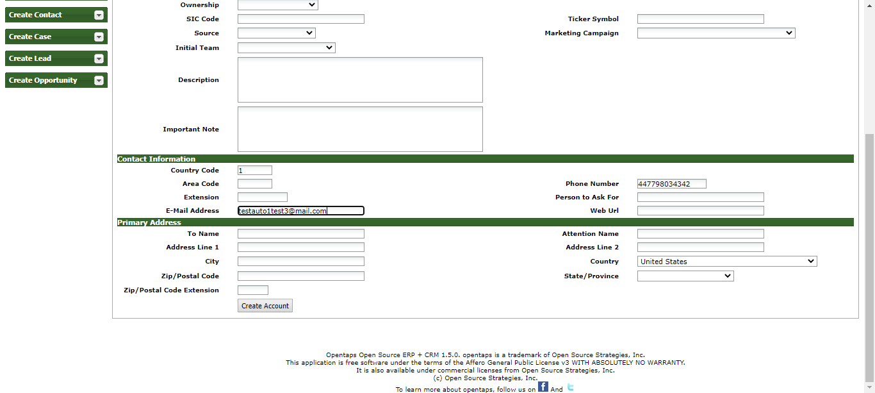

**The Element is clicked**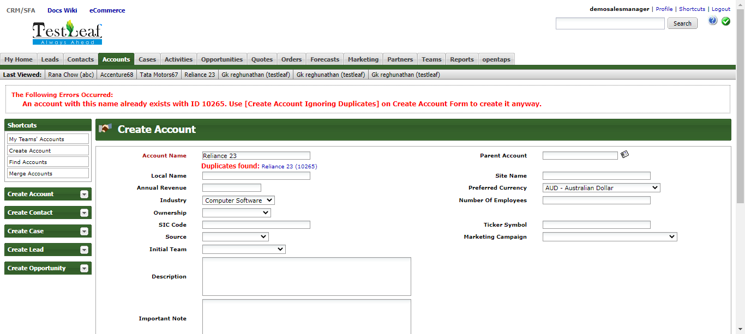

**The Element Create Account is clicked**

**The input Tata Motors67 has been entered sucessfully**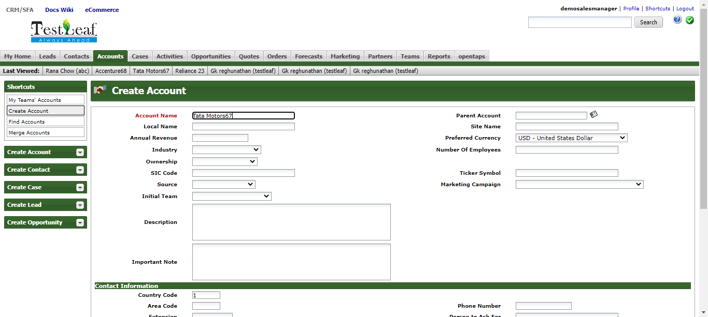

**The input 447798034342 has been entered sucessfully**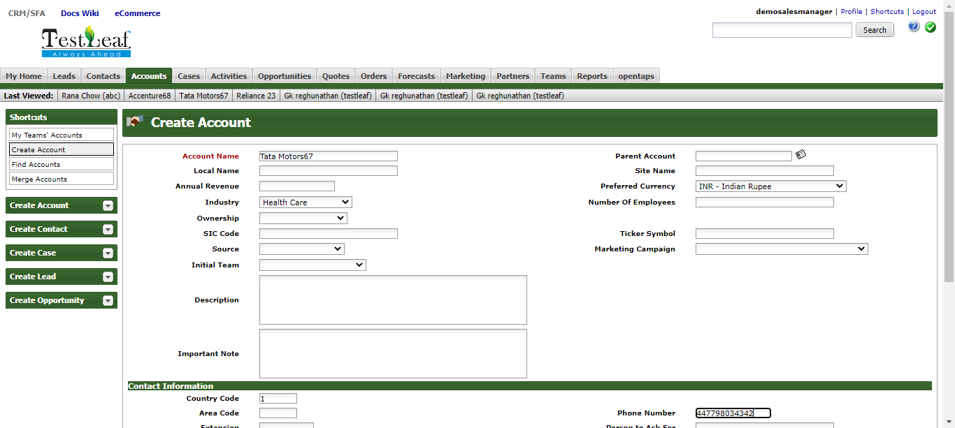

**The input testauto1test2@mail.com has been entered sucessfully**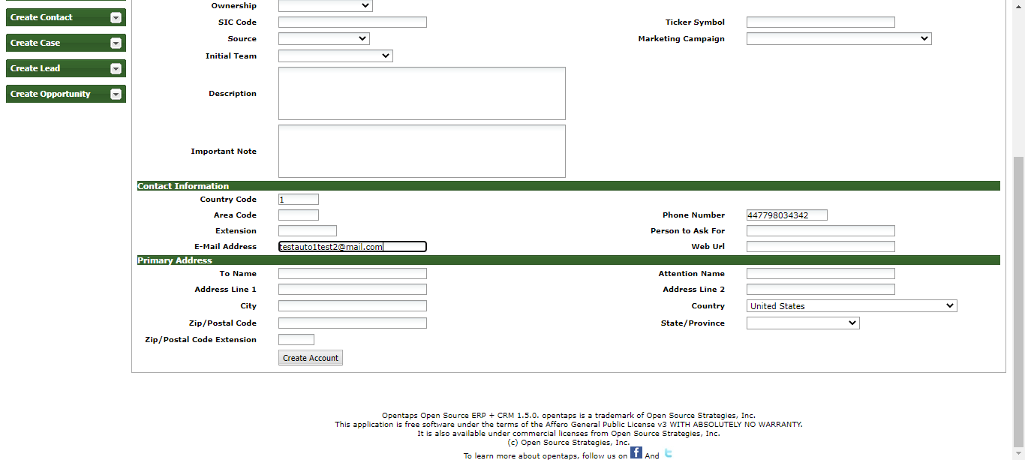

**The Element is clicked**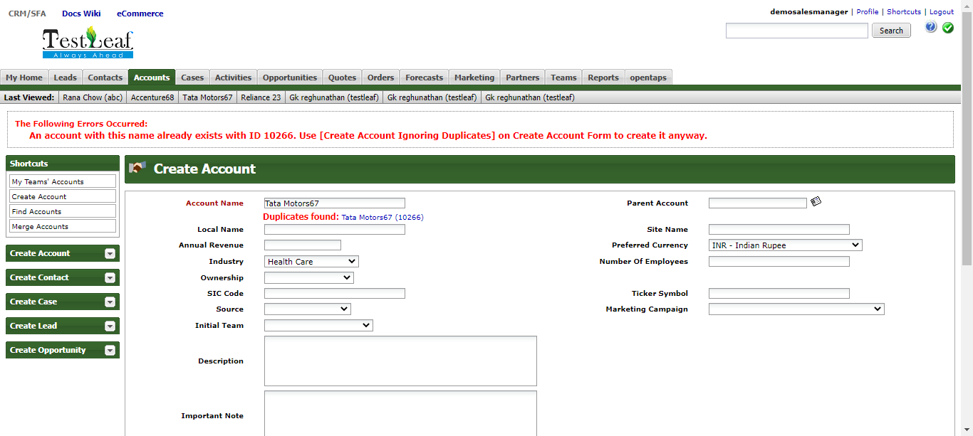

**The Element Create Account is clicked**

**The input Accenture68 has been entered sucessfully**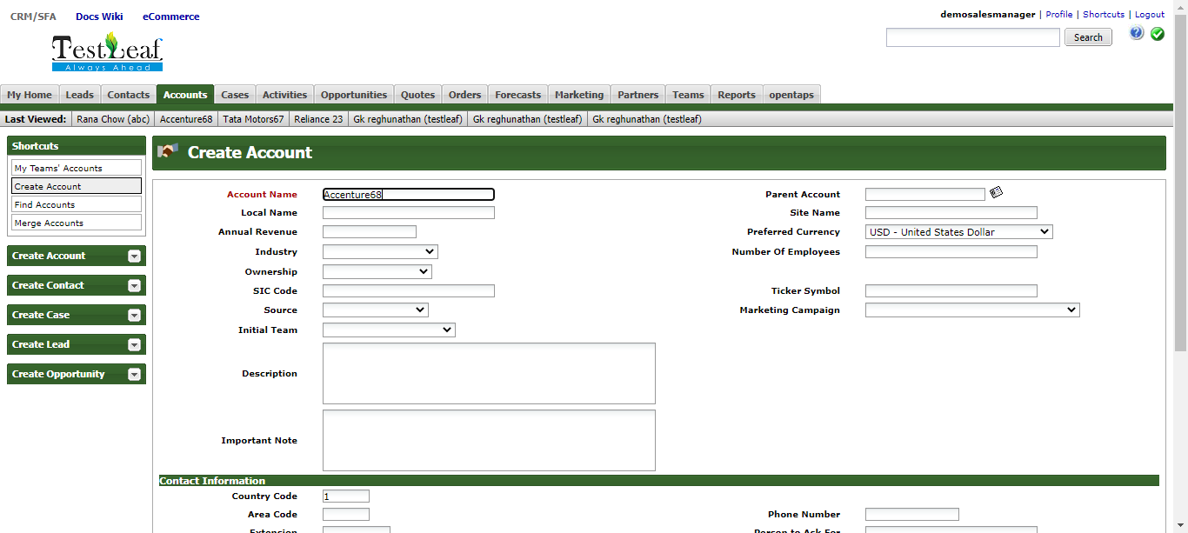

**The input 447798034342 has been entered sucessfully**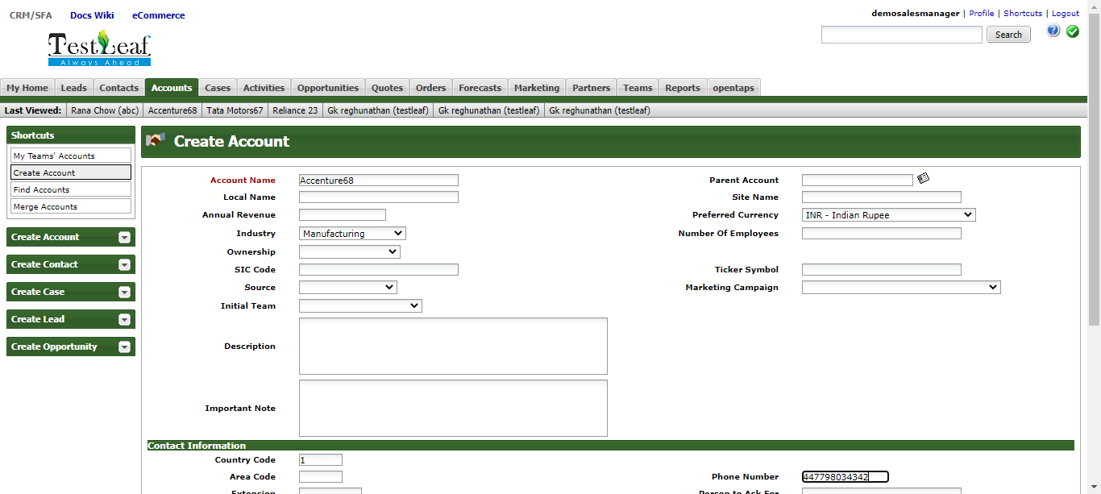

**The input testauto1test1@mail.com has been entered sucessfully**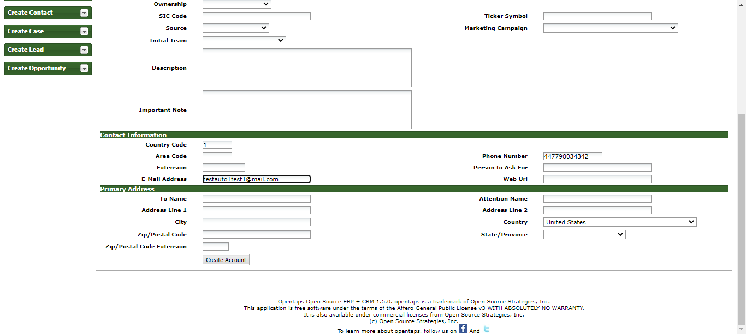

**The Element is clicked**